Before we begin, let's understand a few basics. This kit includes:

• Four Resistors (2x24kΩ, 2x470Ω) 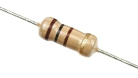

• Three Capacitors, (1x10uF, 1x0.1uF, 1x0.01uF) 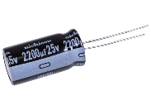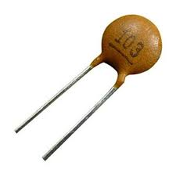

• Two light-emitting diode, 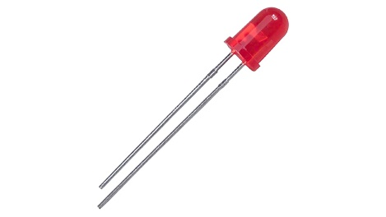

• An integrated circuit (and socket), and 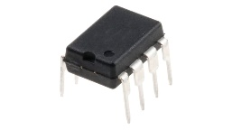

• A solar panel.

The solar panel uses sunlight to make electricity. It's like a water tap. In bright sunlight, the tap is turned on, and electricity flows into the circuit.

A capacitor is like a bucket. When near a tap that's on, it fills up and overflows. When the tap is off, you can tip the water out to keep it flowing.

Resistors reduce the flow of electricity. It's like a hose. If you bend the hose, less water flows through.

A Light Emitting Diode (LED) uses special materials to light up when powered. LEDs only work in one direction, like a one-way street.

Alright, let's build this. Turn the printed circuit board so the scout symbol is on the bottom.

First, we are going to install the capacitors. At the top of the PCB, there are three circles labeled C1, C2, and C3. These are capacitor 1, capacitor 2, and capacitor 3.

Let's start with Capacitor 1. Find the capacitor with “104” written on it, and put it into the two holes in the circle marked C1. To solder the capacitor, put it in the hole. Then, turn the PCB over so the legs stick out on top.

Touch the soldering iron to the leg of the capacitor and the silver hole on the PCB. Touch the solder to the leg and the silver hole. The solder will melt. Add a little more until the leg and hole are covered. Remove the iron. The solder will cool and look shiny. Repeat for the other leg.

Congratulations, you've soldered your first component. Now, flip the PCB back. Find the capacitor labeled '103' (C2) and repeat the process.

Finally, take the last capacitor. This type of capacitor only works one way. The side with the white stripe goes through the white side of the C3 circle. The other side goes through the square hole.

Now we will do the resistors. Below the capacitors, there are four rectangles labeled R1, R2, R3, and R4. The top two are 24K, and the bottom two are 240R. These are the different sizes.

Place all the resistors in front of you. Notice the different colored rings? This shows the size of each resistor. R1 and R2 have Red-Yellow-Orange-Gold rings. R3 and R4 have Red-Yellow-Brown-Gold rings.

Go ahead and solder those resistors in.

Now take the IC socket and solder that into the large rectangle labeled U1. When soldering each leg, use a small amount. Avoid getting solder between the legs.

Flip the PCB over to the Scout Sign side. The LEDs will go in the two spots on each side of the scout sign that don’t already have components in them. Take the two LEDs. Notice the flat side and short leg on one side? That is the negative leg, and it needs to go into the circle hole. The long leg goes in the square hole. Solder those two in.

Lastly, the solar panel connects to the two pads at the bottom labeled J1. Take the red wire and solder it to the square hole, and the black wire to the black hole.

Congratulations, you are finished. Take it into the bright sunshine and see it flash.